**Exercise 2.**

AC Measurement and Analysis Report.

Table of Contents

List of Figures 1

Abstract 3

Part 1: Frequency analysis of the RC circuit 4

Part 2: Analysis of the low-pass filter system 7

Part 3: Analysis of the band-pass filter 10

Part 4: Homework 16

# List of Figures

Figure 1 Tested RC Circuit. 4

Figure 2 Start frequency must be positive. 4

Figure 3 Vout=f(VV1) Plot Characteristic. 5

Figure 4 3dB drop in output frequency. 5

Figure 5 Scheme of a RC circuit with a declaration of a change in the capacity value. 6

Figure 6 Vout=f(VV1) Plot Characteristic. 6

Figure 7 3dB drop in output frequency. 6

Figure 8 LPF Circuit. 7

Figure 9 Vout=f(VV1) Plot Characteristic. 7

Figure 10 Analysis of LPF system. 8

Figure 11 Tested LPF Circuit. 8

Figure 12 Vout=f(VV1) Plot Characteristic. 8

Figure 13 Modified resistor circuit. 9

Figure 14 Plot characteristic of new resistor circuit. 9

Figure 15 Difference between Figure 13 and 11 circuits. 9

Figure 16 Circuit without values of R3,R2 and R1. 10

Figure 17 Calculations for R3, R2 and R1. 10

Figure 18 Circuit with values of R3, R2 and R1. 11

Figure 19 Presents the band pass characteristic of our filter. 11

Figure 20 Design Calculations 11

Figure 21 Presents tested circuit with changed 20% parameters. 12

Figure 22 Characteristic of circuit Figure 21. 12

Figure 23 Circuit for determining the capacitance for f0=5kHz. 13

Figure 24 Plot for determining the capacitance for f0=5kHz. 13

Figure 25 use of the .meas command. 13

Figure 26 Plot characteristic. 14

Figure 27 SPICE Error Log measurement results. 14

Figure 28 Tested circuit with new range. 15

Figure 29 Plot Characteristics. 15

Figure 30 Error log info. 15

Figure 31 Homework Circuit 16

Figure 32 Presents the UA741 circuit design. 16

Figure 33 Presents plot characteristic. 17

Figure 34 Gain. 17

Figure 35 Voltage Measured. 17

Figure 36 Center Frequency f0. 18

Figure 37 20% Influence of R1 19

Figure 38 20% Influence of R2 and R3 19

Figure 39 20% Influence of R4 and R5 19

Figure 40 20% Influence of C1 and C2 19

# Abstract

The aims of this laboratory exercise were to introduce an AC voltage source from the theory to practice. The aims of this report are to learn about possibilities of AC analysis, frequency characteristics, testing characteristics of filters and performing regular calculations in LTspice.

# Part 1: Frequency analysis of the RC circuit

To start I have firstly created a diagram of the tested RC circuit.

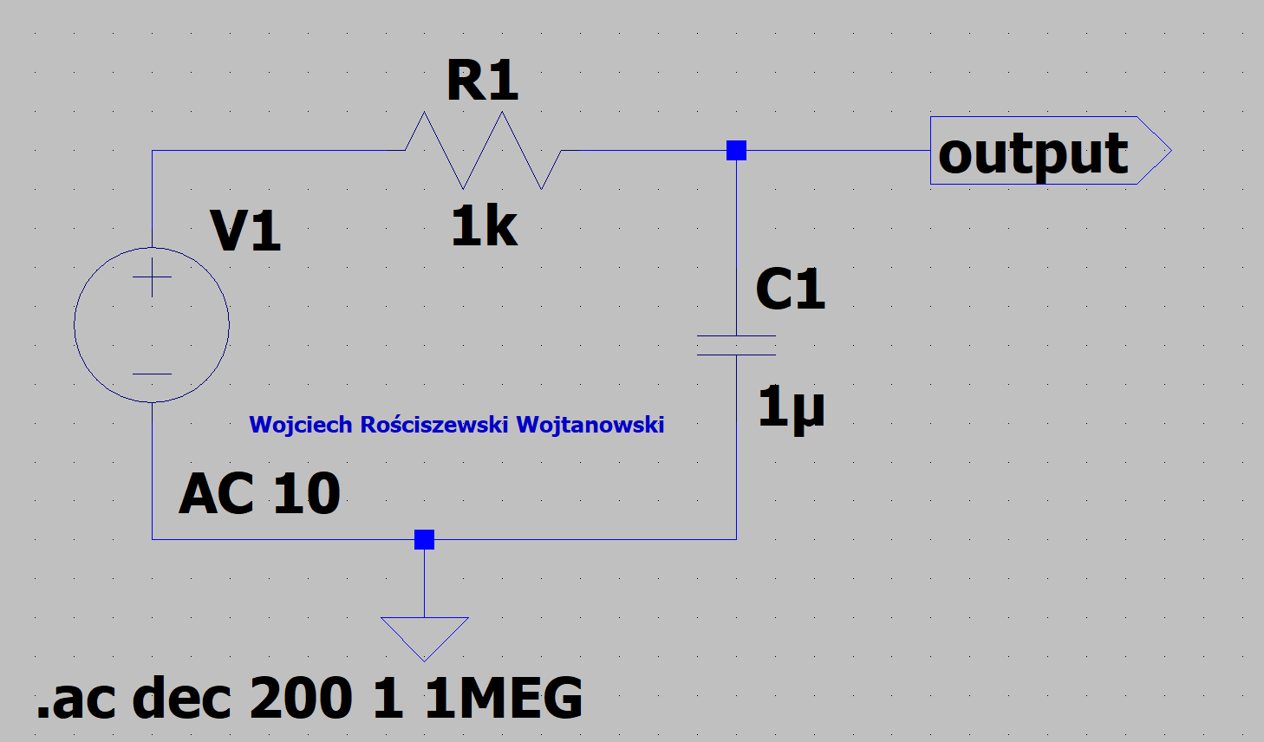

Figure 1 Tested RC Circuit.

Please see the following labels: Voltage Source labelled as V1, resistors labelled as R1, capacitor labelled as C1, Label OUT is output and the triangle at the very bottom of the figure is the ground. These few components in this digital simulator enables us to create our testing circuit.

In figure 1 please see the following command SPICE directive “.ac dec 200 1 1MEG”, this is the simulation command known as the decade sweep in AC analysis. Sometimes when we analyze a filter, we do not use the linear function but rather observe the decade frequency. The number of probes were set to 200, for information the number of probes cannot be set to 0 since beginning at that frequency isn’t allowed in the SPICE directives, therefore we must start at 1 and ending with 1MEG.

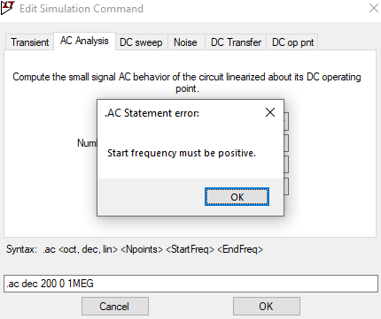

Figure 2 Start frequency must be positive.

Values of each component have been entered manually, as per instruction, by clicking with the RMB over each component. Seek: R1 set to 1000Ω (1kΩ), capacitor set to 1μ voltage source V1 set to AC 10V. To continue further we must produce a characteristic plot of the Vout function of V1 – so Vout=f(VV1).

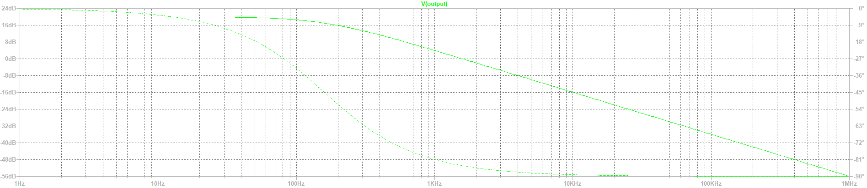

Figure 3 Vout=f(VV1) Plot Characteristic.

In figure 3 please seek the analysis of the characteristic of our AC plot. From this graph we see that it is in fact a low pass filter. We can see this since the low frequency on this tested circuit can go through whilst the high frequencies have a problem in passing through the tested circuit, of course referring to circuit from figure 1.

Next step is to read a 3dB drop in the output frequency of our tested circuit, however this time we make a small alteration to our circuit.

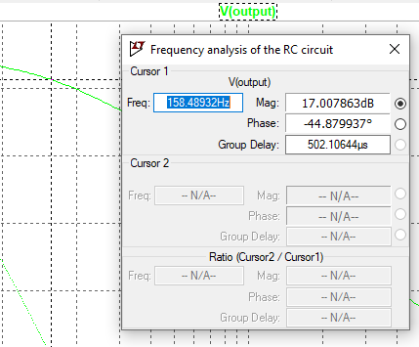

Figure 4 3dB drop in output frequency.

Please see that we now change the value of capacitor C1 from 1μ to “{cc}” and then using this variable name we must not set the “.param cc=1u” and a step direction function “.step param c list 0.1u 1u 10u”. Note that all “u” notation provided represents micro μ.

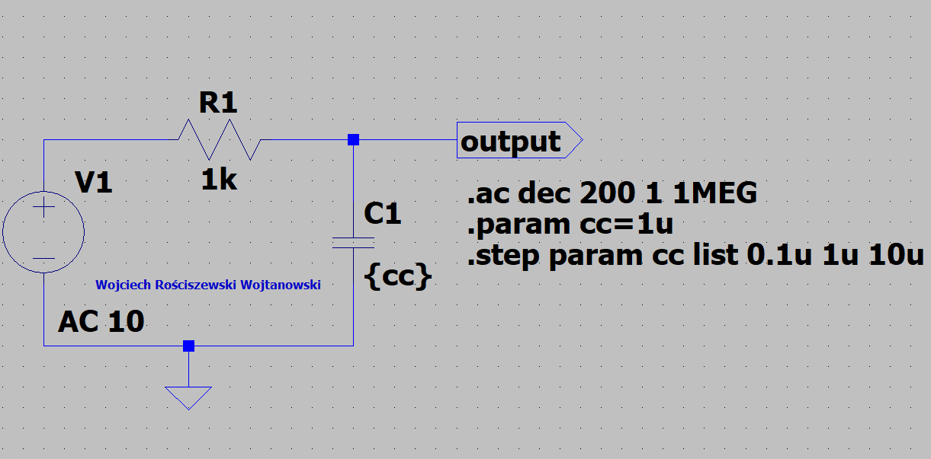

Figure 5 Scheme of a RC circuit with a declaration of a change in the capacity value.

In the below please find the output characteristic, we see out frequency values as well as our decibel scale level.

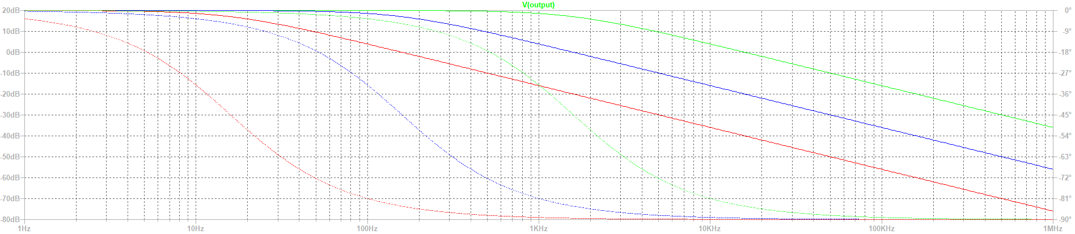

Figure 6 Vout=f(VV1) Plot Characteristic.

Here we see, that in Figure 6 we see no difference between Figure – plot wise no difference. However, only remarkable difference can be noticed in the structure of how the circuit is used (using syntax commands) and the fact we have far more curves visible in our graphs. I now test the 3dB level.

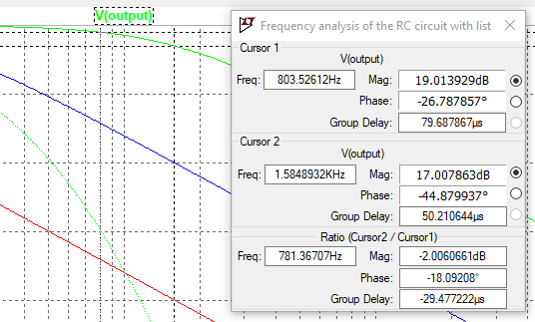

Figure 7 3dB drop in output frequency.

# Part 2: Analysis of the low-pass filter system

To start the second part of this laboratory I have firstly created a diagram of the low pass filter circuit, see that in comparison to previous circuit we not have an operational amplifier used, specifically the OP27, so we set the positive and negative voltage sources (+-15V) and constructed our AC filtration system. Please seek Figure 10 that presents the described circuit.

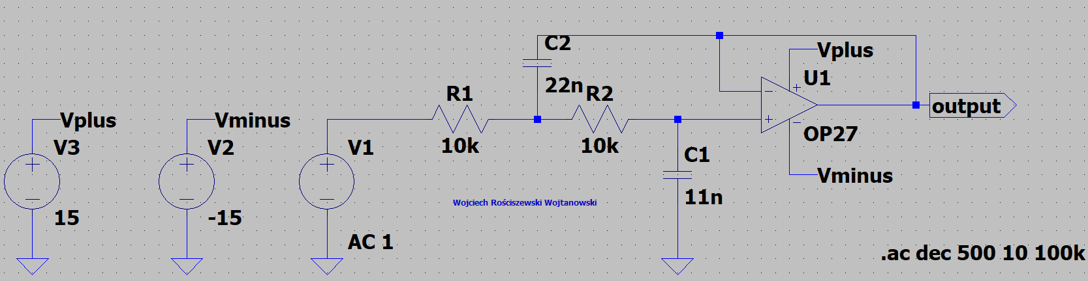

Figure 8 LPF Circuit.

Please note that the .ac syntax has changed as well as the AC sweep command syntax.

The next step of the experiment is to run the simulation with the new AC LPF circuit with new elements as seen in Figure 10.

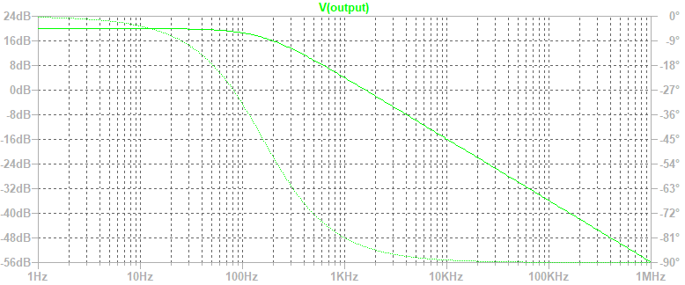

Figure 9 Vout=f(VV1) Plot Characteristic.

I have then read the frequency value from the characteristics that correspond to the 3dB drop in the output voltage. Please see Figure 12 where this information is presented.

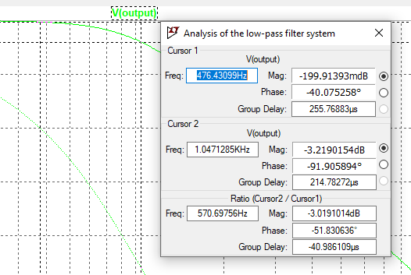

Figure 10 Analysis of LPF system.

Moving on forward, we now see a modified version of the circuit previously seen in figure 8, it is visible that we have now set a variable parameter for C2 and C1, “C2={x*22n}” and “C1={x*11n}” and with the correct use of the directive SPICE syntax in this case “.param x=1” & “.step param x list 0.5 1 1.5” we have successfully modified the circuit to influence the capacitance value on the characteristics, therefore the values taken here are +-50% of the original value. Please see Figure 11 that presents this circuit, also please see the simulation run that presents the output voltage as a function of frequency being Figure 12.

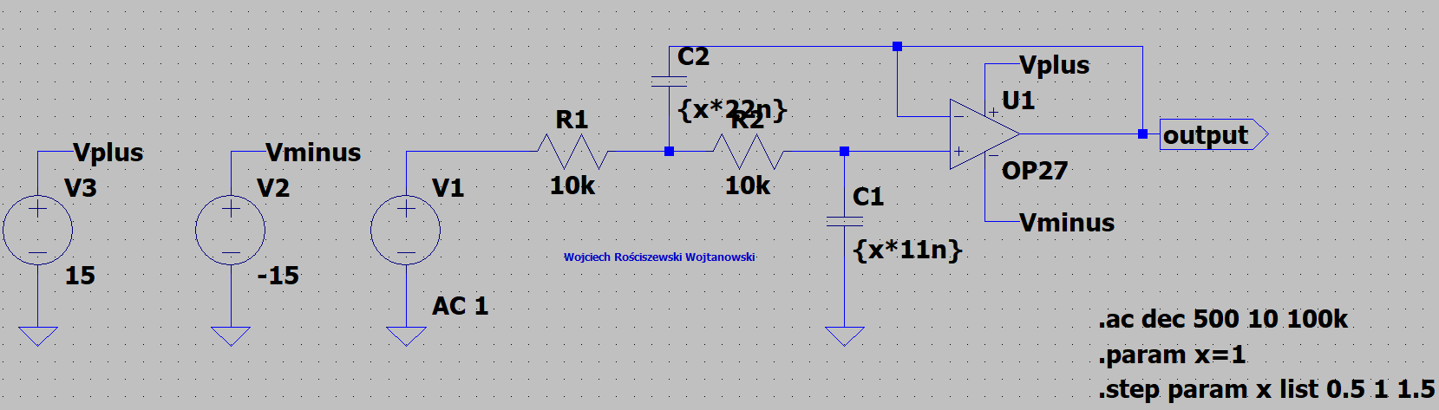

Figure 11 Tested LPF Circuit.

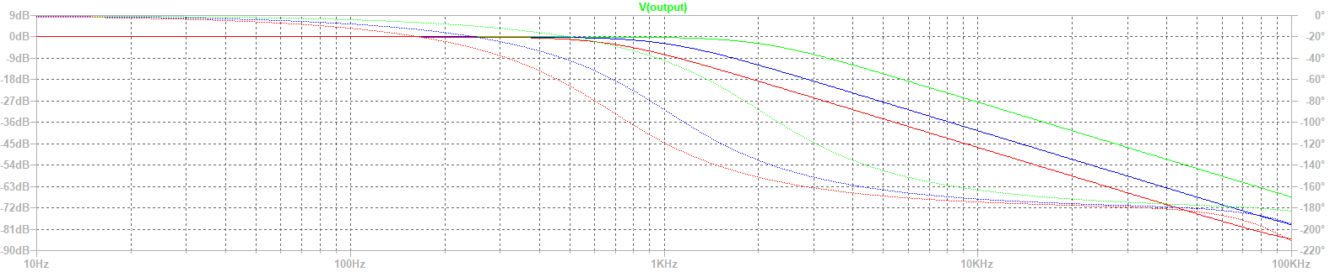

Figure 12 Vout=f(VV1) Plot Characteristic.

To finish of this part of the experiment I have not modified the circuit in such manner so that the values of R1 and R2 will change +-20%.

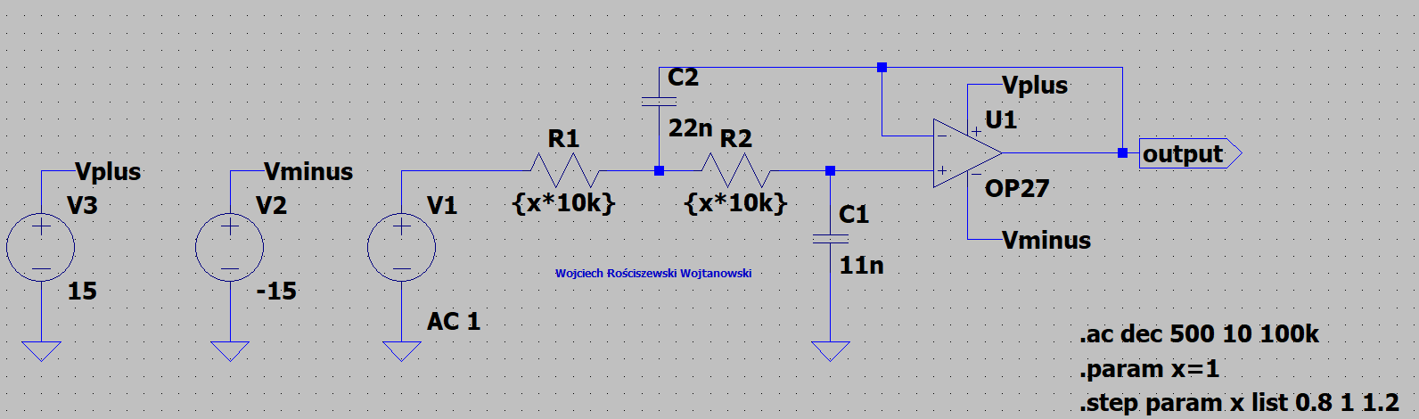

Figure 13 Modified resistor circuit.

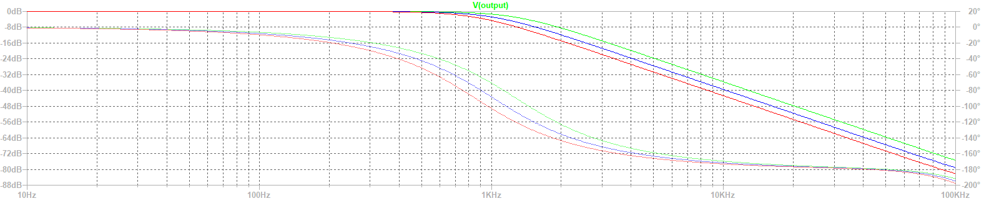

Figure 14 Plot characteristic of new resistor circuit.

What changed? Please see the figure below presenting the differences. Not window on the left presents the values of circuit from Figure 13 whilst the figure below presents the circuit from Figure 11.

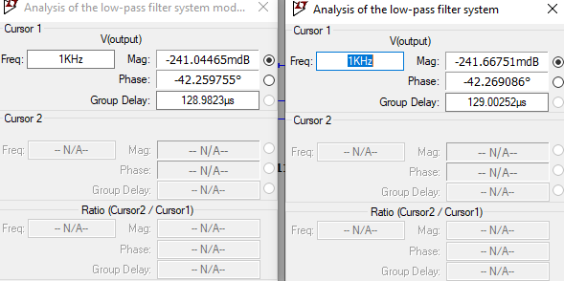

Figure 15 Difference between Figure 13 and 11 circuits.

# Part 3: Analysis of the band-pass filter

For this part of the laboratory we now must calculate the values of three provided resistors.

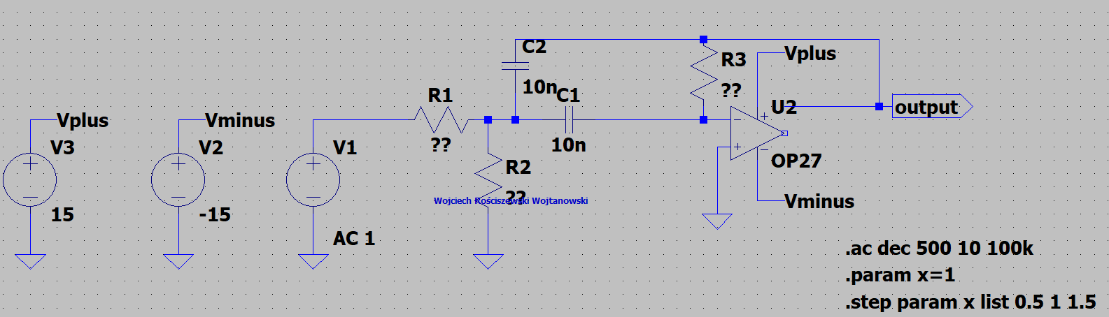

Figure 16 Circuit without values of R3,R2 and R1.

A visible error can be spotted in fact on this circuit, as the output is not connected to our opamp. This is a strong lesson as I have spent some time not able to make the circuit run, therefore always check your circuit.

In the figure 17 please find the equations used to calculate the resistance values, according to the provided band pass filter assumption values provided below:

* Capacitors = 10nF,
* Center Frequency f0=1kHz,
* Quality filter Q=5,
* Gain for f0 frequency kv=1

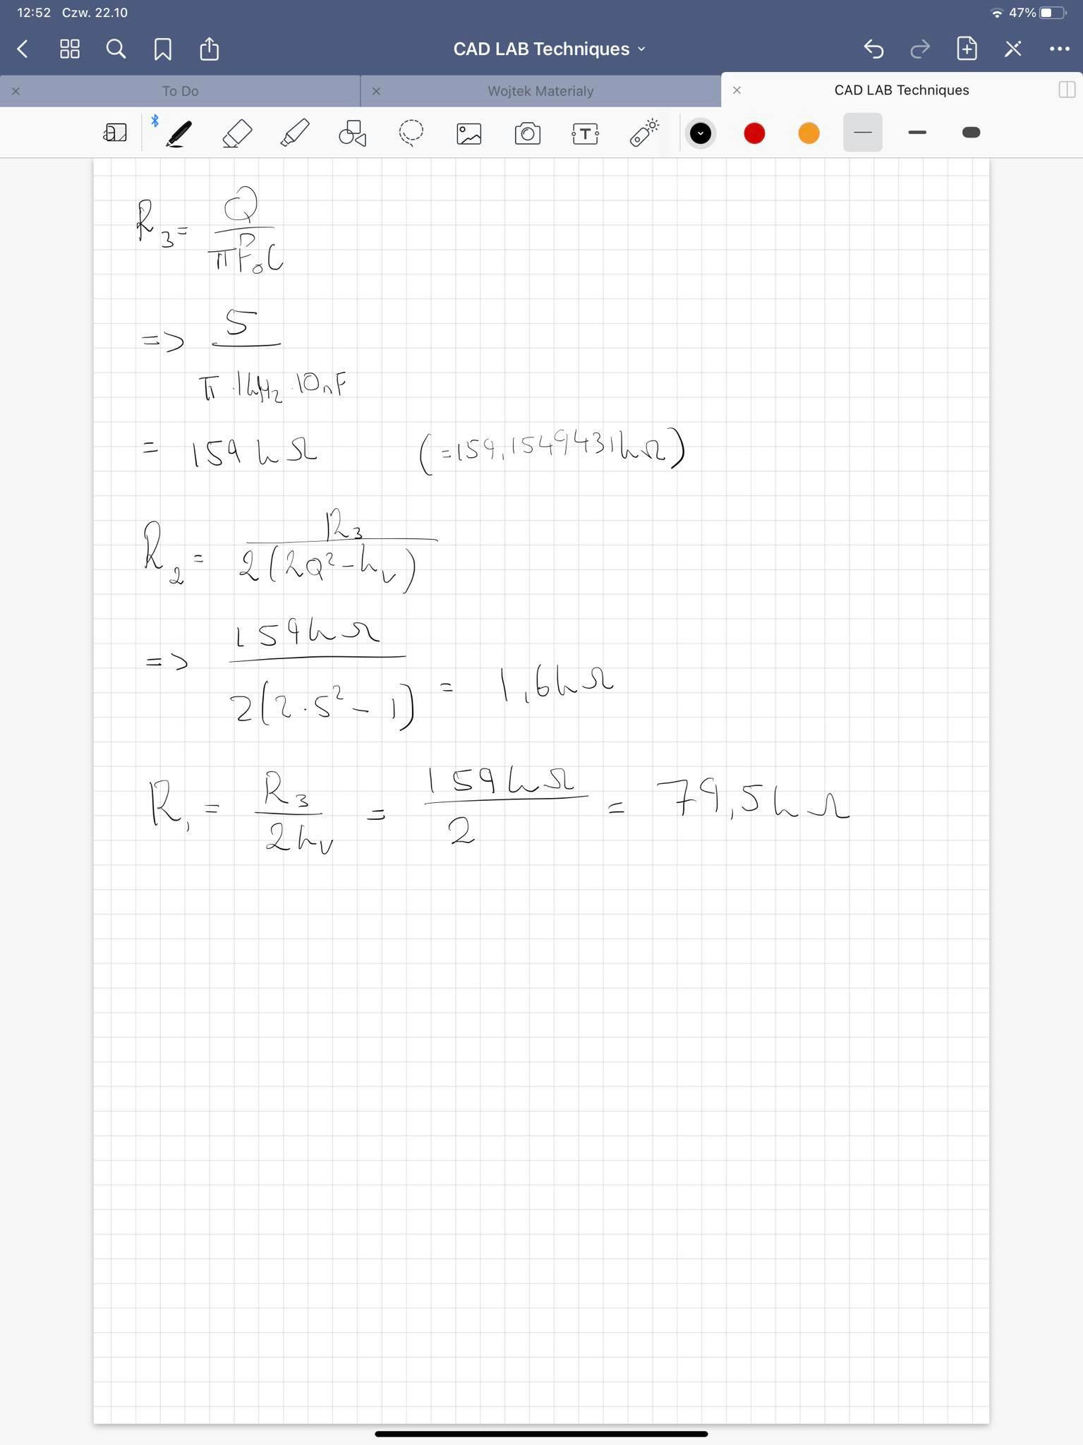

Figure 17 Calculations for R3, R2 and R1.

Rounding all values up we receive. R3=160kΩ, R2=1,6kΩ, R1=80kΩ. See figure 18 presenting this circuit.

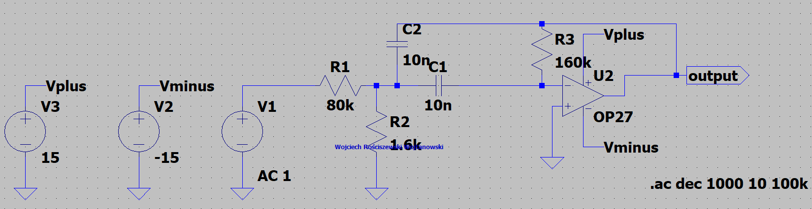

Figure 18 Circuit with values of R3, R2 and R1.

Please see figure below that presents the output of the system from Figure 19.

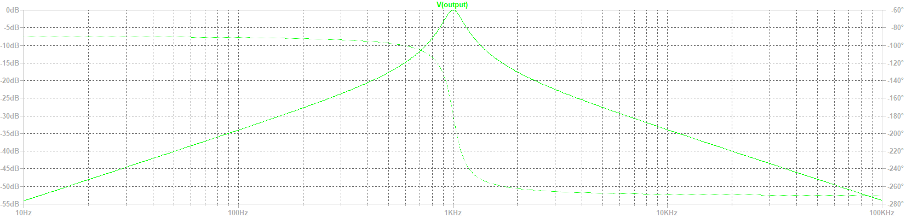

Figure 19 Presents the band pass characteristic of our filter.

To give some overview of how this filter functions I have again removed all values from the marked resistors and ran the circuit. Please see filter parameters and comparison between values with design calculations:

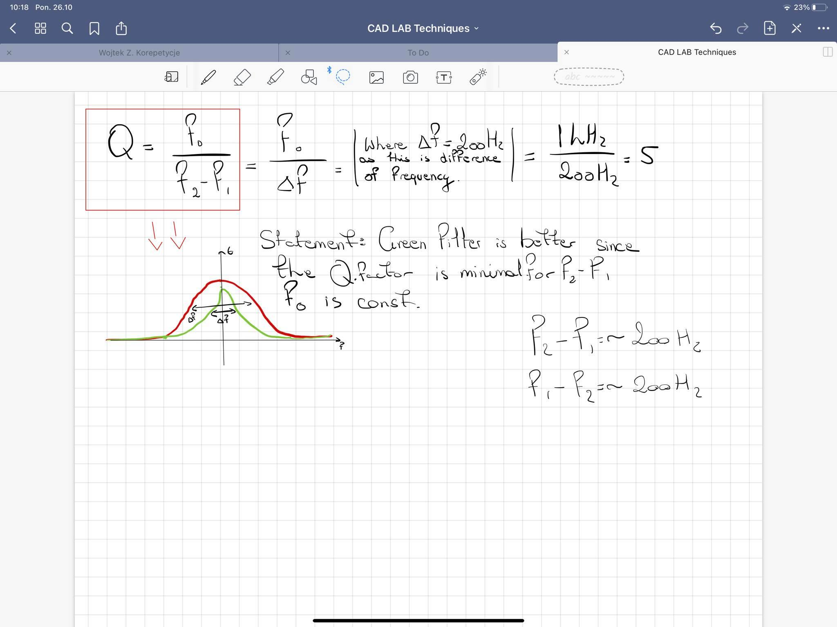

Figure 20 Design Calculations

The next part of the report is to modify the circuit in such manner so that all elements such as the resistors and capacitors will have their values modified with the influence of +-20% of their original values. To do so I have used the same method as in the Analysis of the low-pass filter system task. Below please find the circuit tested as well as the run simulation results presenting the changed characteristic. Of at which frequencies the filter starts to pass and stop.

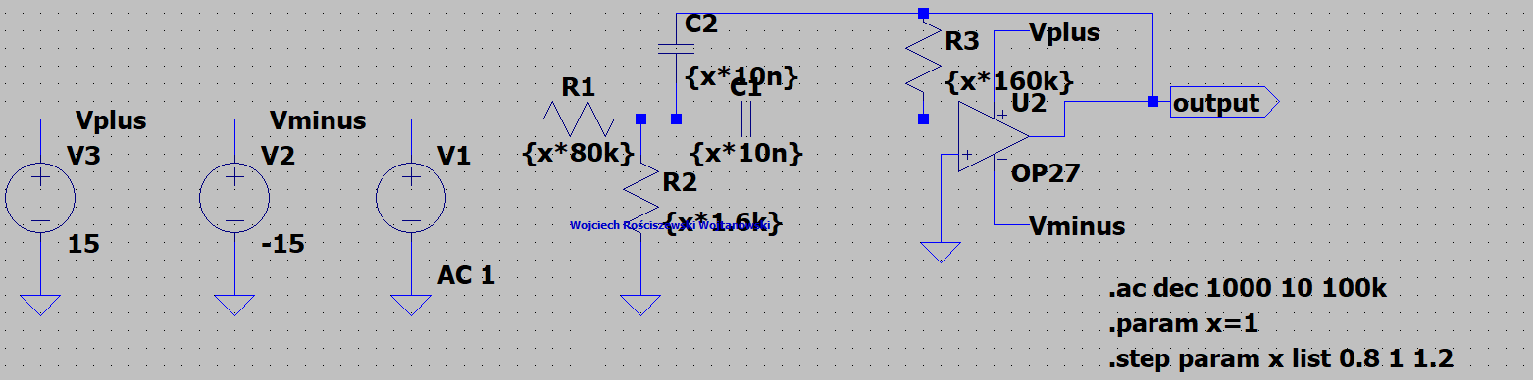

Figure 21 Presents tested circuit with changed 20% parameters.

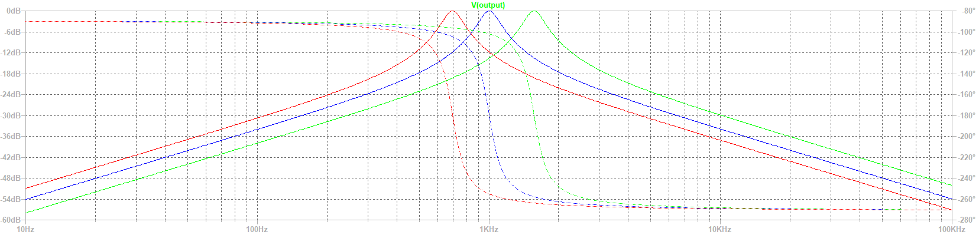

Figure 22 Characteristic of circuit Figure 21.

For the next part of the laboratory we must determine the capacitance values for C1 and C2 where the filter will have the center frequency f0 = 5kHz. Please see tested circuit in figure below that presents the determination of such capacitance.

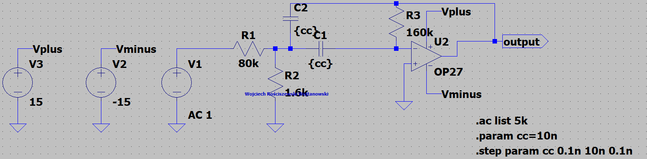

Figure 23 Circuit for determining the capacitance for f0=5kHz.

In the figure below please see the results of plot characteristic for circuit shown in Figure 23.

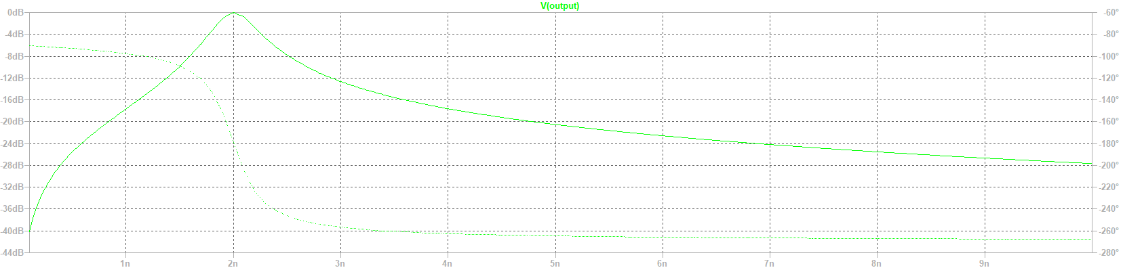

Figure 24 Plot for determining the capacitance for f0=5kHz.

Please see that when we have output voltage of 1V, our capacitance is 2nF.

Now we introduce the .meas command that sets the filter parameters. Please see Figure 25 that presents the new modified circuit that contains new syntax to complete this task.

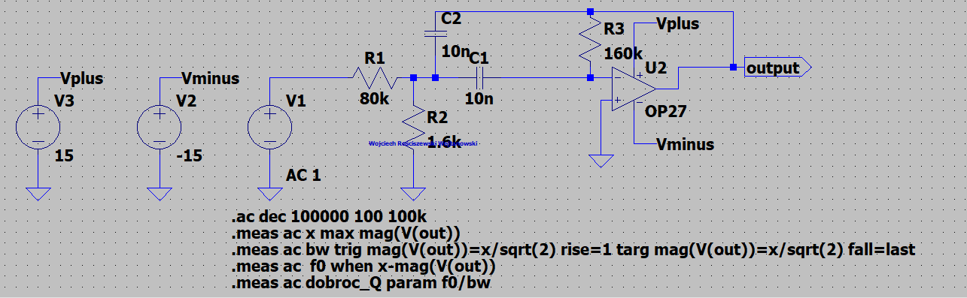

Figure 25 use of the .meas command.

Below please see the characteristic provided.  
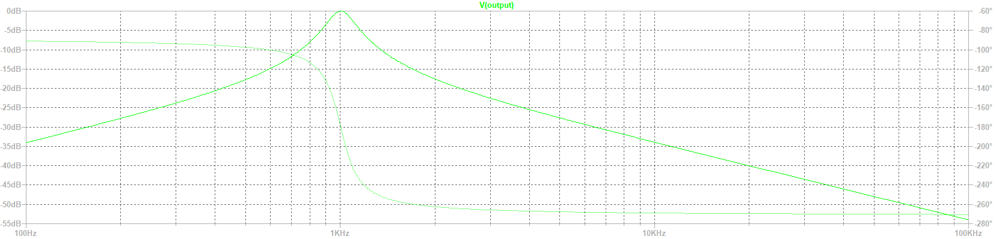

Figure 26 Plot characteristic.

To see the calculation results we must access the SPICE error log file that provides all values. Please see figure 27 that presents such results. Please note that I have received many errors from this step, my issue was that the output label should be labelled as “out” just as in the SPICE directive – seems like a pretty obvious step however it is worth to mention to look out for this in the future.

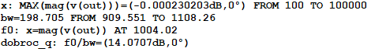

Figure 27 SPICE Error Log measurement results.

One of the last tasks is to change the capacitance values in a specific range, from 10nF to 20nF with a step of 1nF, please refer to the work incrementation every time I use the word step.

Please find the circuit figure in the below that presents this change as well as the plot characteristic.

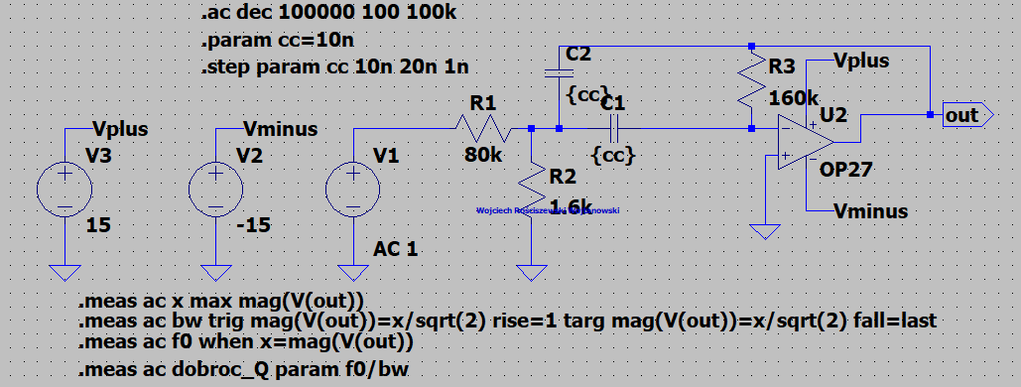

Figure 28 Tested circuit with new range.

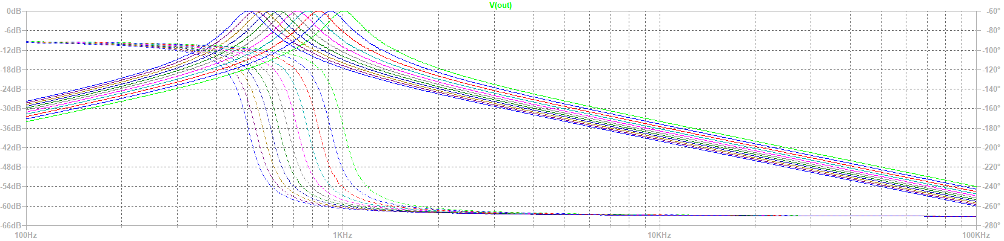

Figure 29 Plot Characteristics.

From what we can see the higher the capacitance of our capacitors is the lower the peak frequency of 1V on output. Below please see the contents of the spice error log.

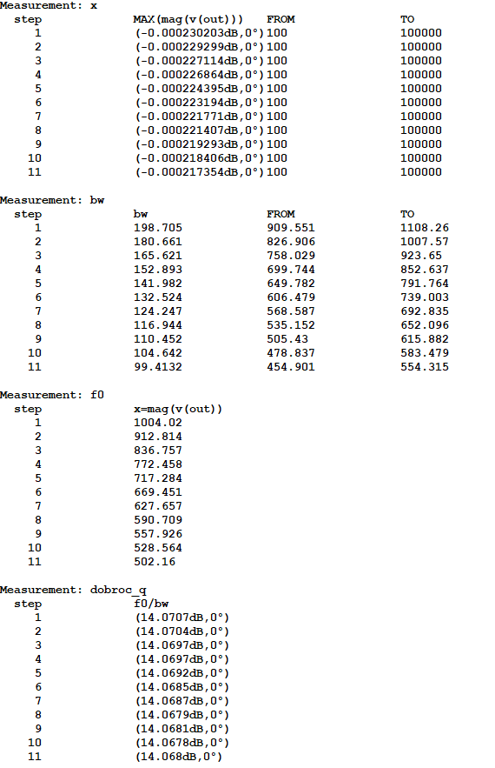

Figure 30 Error log info.

# Part 4: Homework

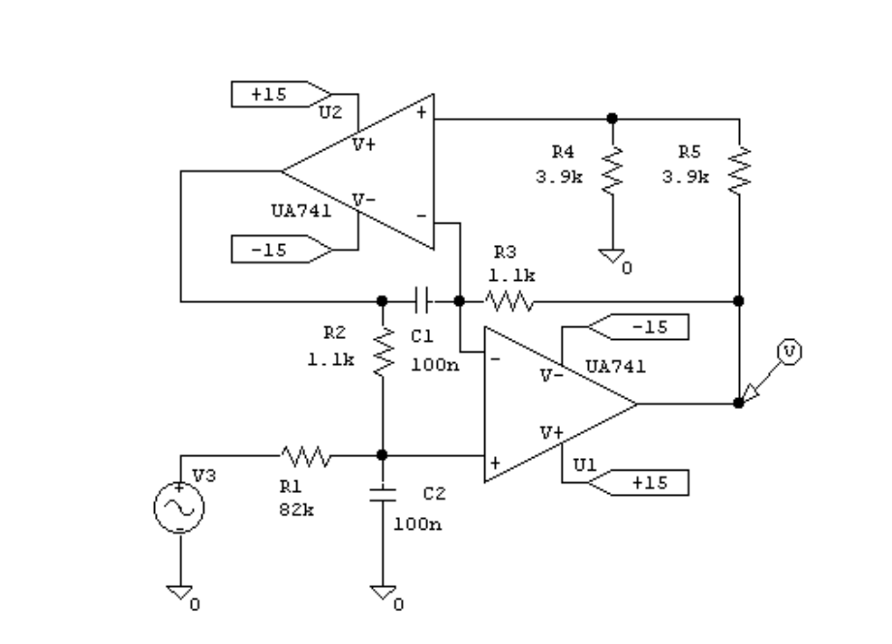

Figure 31 Homework Circuit

In the below please see the following UA741 circuit drawn in LTSpice software, please see the parameters included as well as the Figure below presenting the frequency characteristic.

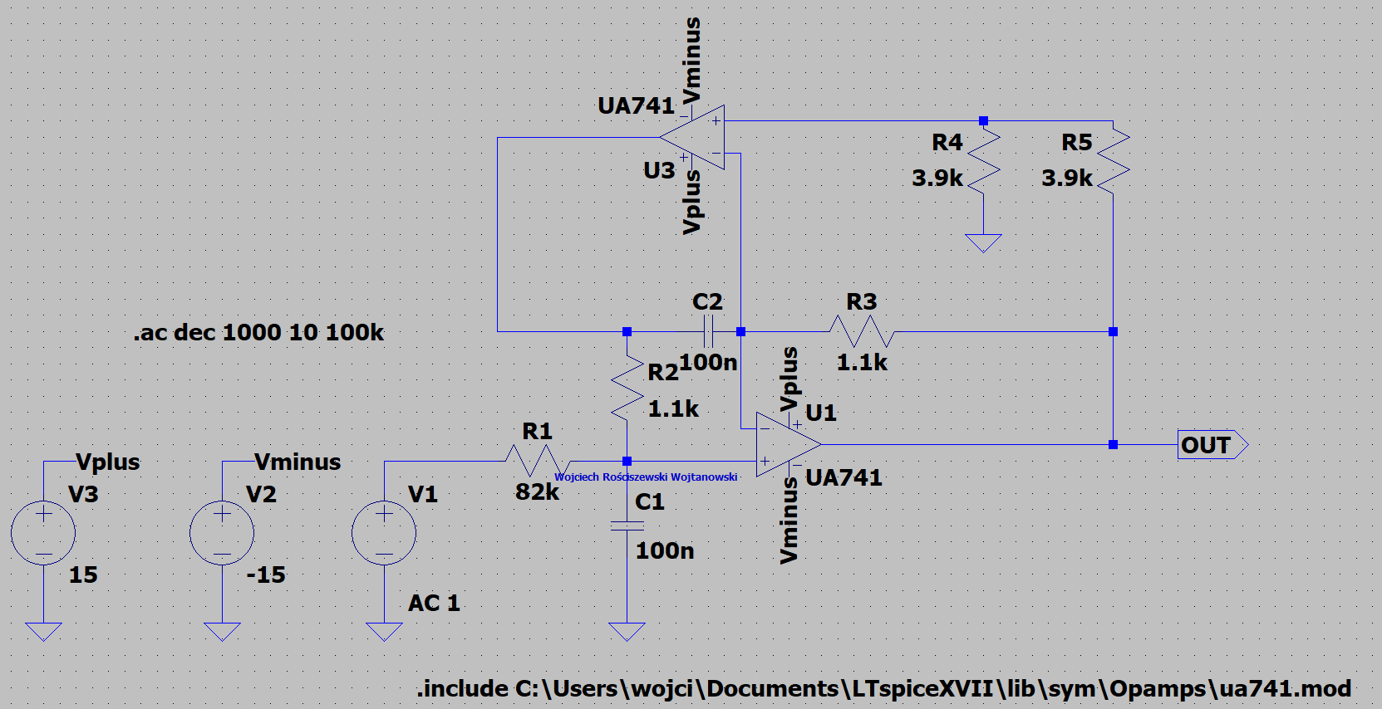

Figure 32 Presents the UA741 circuit design.

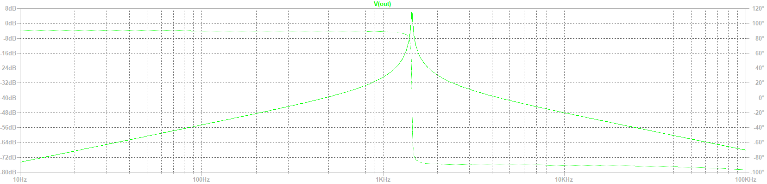

Figure 33 Presents plot characteristic.

We have a band-pass filter constructed with use of two op amps. Very interesting activity. We see the band pass component as well as the low pass filter behind it. One interesting note is that in Figure 33 we see the filter overshoot, so some band pass filter gain can be seen. With the axis changed in figure 33 we see that the peak voltage at Vout is 2.07V (Figure 35). Which in fact is correct that we have 2V, the gain of the filter is its center frequency, so it is the total pass band gain. I only suppose that this is a good way to describe gain visible, that by cascading of the high and low pass filters with our amplifying components we have created a band pass filter, so the circuit between these high and low pass filter will give out over all some voltage gain of the circuit.

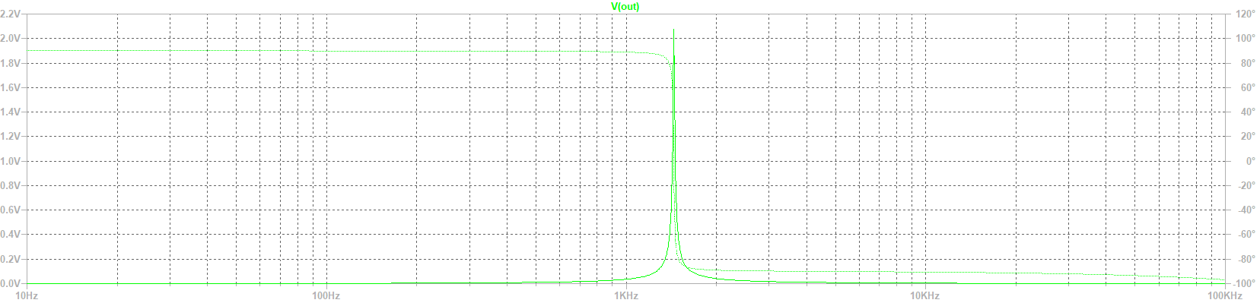

Figure Gain.

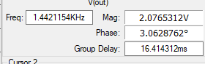

Figure 35 Voltage Measured.

Next part of the homework task is to set the values and check the influence of the system, please see the following figures described in their caption of what they are as well as a conclusion under them.

Also, before moving on forward please see the cutoff frequency of the presented circuit.

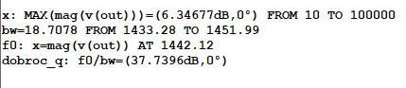

Figure 36 Center Frequency f0.

Visible we see that the center frequency is 1,442kHz.

Below please find the results of the 20% influence on specific elements, Figures 37 – 40).

20% Influence of R1:

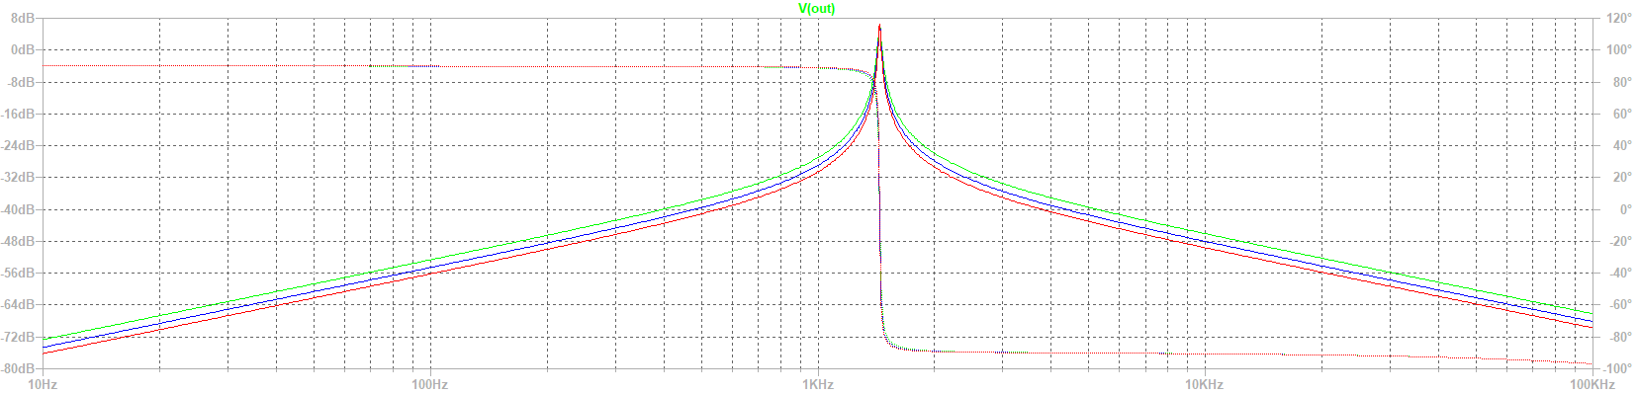

Figure 37 20% Influence of R1

20% Influence of R2 and R3:

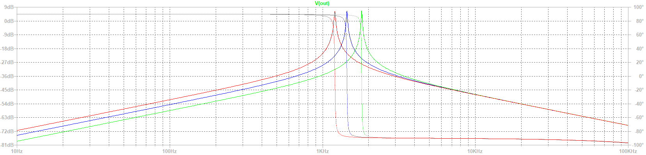

Figure 38 20% Influence of R2 and R3

20% Influence of R4 and R5:

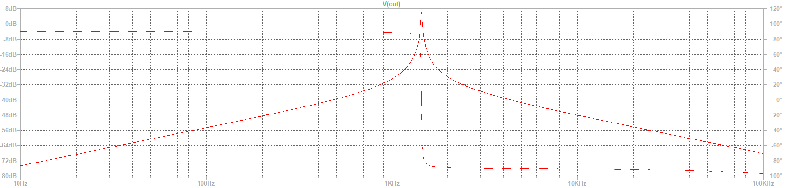

Figure 39 20% Influence of R4 and R5

20% Influence of C1 and C2:

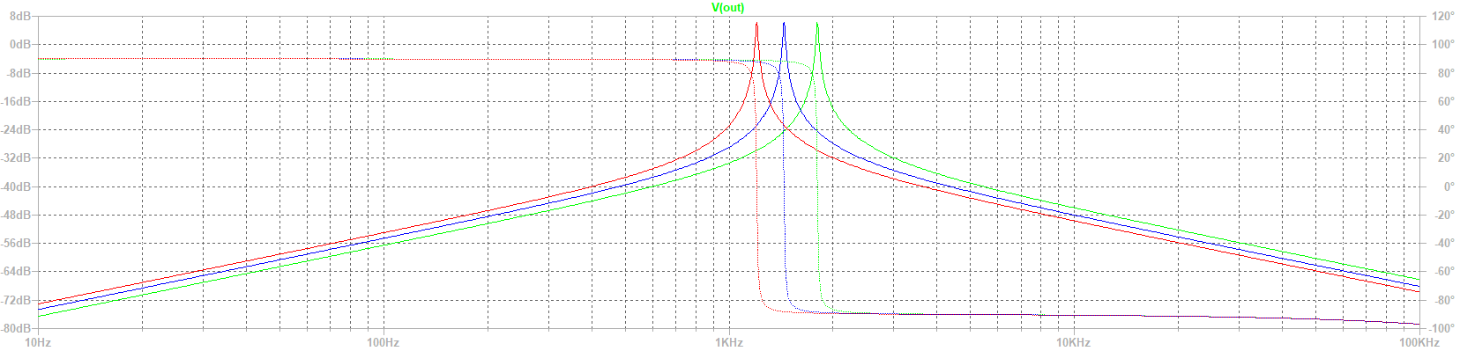

Figure 40 20% Influence of C1 and C2

From the visible graphs between Figures 37 to Figure 40 we see that… R1 resistor value influences the stop band region. The influence of R2 and R3 influences the frequency else the center wavelength f0. Influence of resistor R4 and R5 are slim to none in the circuit. Whilst the influence of capacitors influences the rejection in the filter just as the R1 influences the stop band region also the center frequency is shifted to a different frequency. The higher the capacitance the lower the center frequency visible and vice versa.

In the zip file attached please also find the simulation model used during this homework task.